Student Name: _______________________

Narrogin Senior High School

YEAR 11 HISTORY EXAMINATION PAPER

SEMESTER TWO 2009

HISTORY DOCUMENT BOOKLET

CONTENTS:

DOCUMENT AREA OF STUDY RELATED
SET QUESTION

- Document Germany 1919-1945 Complete all (a) – (g)
Study within answer booklet

- Essay
Questions Germany 1919-1945 Choose 1 of 3

- Essay
Questions Germany 1919-1945 Choose 1 of 3

Source 1
‘The Allied Governments affirm, and Germany accepts, the responsibility of Germany and her allies for causing all the
losses and damage to which the Allied Governments and
peoples have been subjected as a result of War.’

Article 231 of the Treaty of Versailles.

Source 2

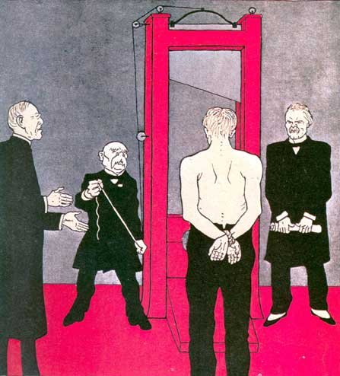

Political cartoon that appeared in the German magazine Simpliccimus on June 3, 1919.
The principal judges and executioners were (from left to right) the American President Wilson, the French President Clemenceau and the British Prime Minister Lloyd George.

Source 3

A British cartoon from Punch magazine, 8 March 1933.

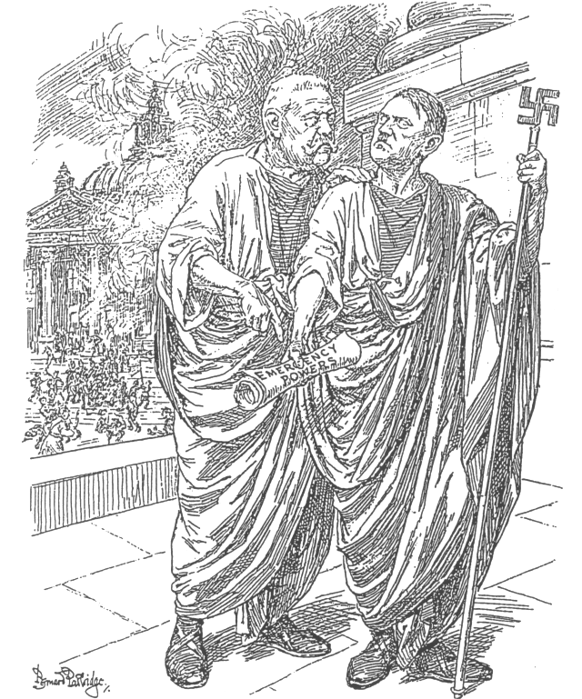

The Old Consul (to Hitler). “THIS IS A HEAVEN-SENT OPPORTUNITY, MY LAD.
IF YOU CAN’T BE A DICTATOR NOW, YOU NEVER WILL BE.

Source 4

“There had been a big Nazi meeting at the Sportsplatz (sports stadium), and groups of men were just coming away from it in their brown or black uniforms. Walking along the pavement ahead of me were three S.A. men…. All at once they came face to face with a youth of 17 or 18 dressed in civilian clothes…. I heard one of the Nazis shout ‘That’s him’, and immediately all three of them flung themselves upon the young man. He uttered a scream and tried to dodge, but they were too quick for him. In a moment they had jostled him into the shadow of a house entrance and were standing over him, kicking and stabbing at him with the sharp metal points of their banners…. Another passer-by and myself were the first to reach the doorway where the young man was lying. He lay huddled crookedly in the corner, like an abandoned sack. As they picked him up, I got a sickening glimpse of his face – his left eye was half poked out, and blood poured from the wound…. By this time, dozens of people were looking on. They seemed surprised but not shocked – this sort of thing happened too often nowadays…. Twenty yards away stood a group of heavily armed policemen. With their chests stuck out and their hands on their revolver belts, they magnificently disregarded the whole affair.
Almost every evening, the S.A. men came into the café. Sometimes they are only collecting money; everybody is compelled to give something. Sometimes they have come to make an ‘arrest’. One evening, a Jewish writer who was present ran into the telephone box to ring up the police. The Nazis dragged him out, and he was taken away. Nobody moved a finger. You would have heard a pin drop till they were gone.”

An account from an English writer living in Berlin 1932-33

Source 5

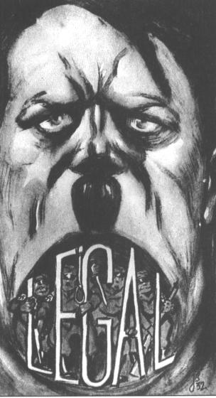

“Hitler’s interpretation of the word “legal”.

A cartoon from the Social Democrat Magazine, 1932.

